Kate Porterfield

Policoff

Global Writing Seminar

25 October 2017

Music Inn: World Instruments and Village Enigma

West 4th Street is a true reflection of the spirit of Greenwich Village. A plethora of international businesses line the worn pavement, with smells of damp concrete and coffee shops mixing in the muggy air. Nestled in-between an Indian take-out restaurant and a sex shop that has gone well out of business is a store unlike any other: Music Inn World Instruments, commonly known as Music Inn. The entrance to the shop is unassuming: a wooden door painted black to match the walls of the storefront, with windows previewing a sampling of guitars and drums stationed inside. Black piping dotted with brass orbs borders large white block letters spelling the word, “MUSIC INN”.

I did not intend to venture into Music Inn. My friend, Bill, had a desperate need to play a tuned piano, so when we saw the glint of a guitar in the store window, we jumped into the store in hope that a piano might be present as well. While we did not see a piano, what we found instead were hundreds of vinyl records. Stacks upon stacks of artists lined the walls, from symphonic classics to the Pretenders. As Bill and I perused the collection while listening to a man in the corner fool around on a ukulele, a voice from behind said, “Do you need anything, or can I go get my coffee?”

I turned to see a man as old as time, his face lined with wrinkles deep from years of laughter covered by a large pair of wire glasses, wearing a loose plaid shirt over a pair of olive green work pants. “No, we’re just looking” I replied.

“Great,” he said, and then stepped out of the front door to pursue his caffeine.

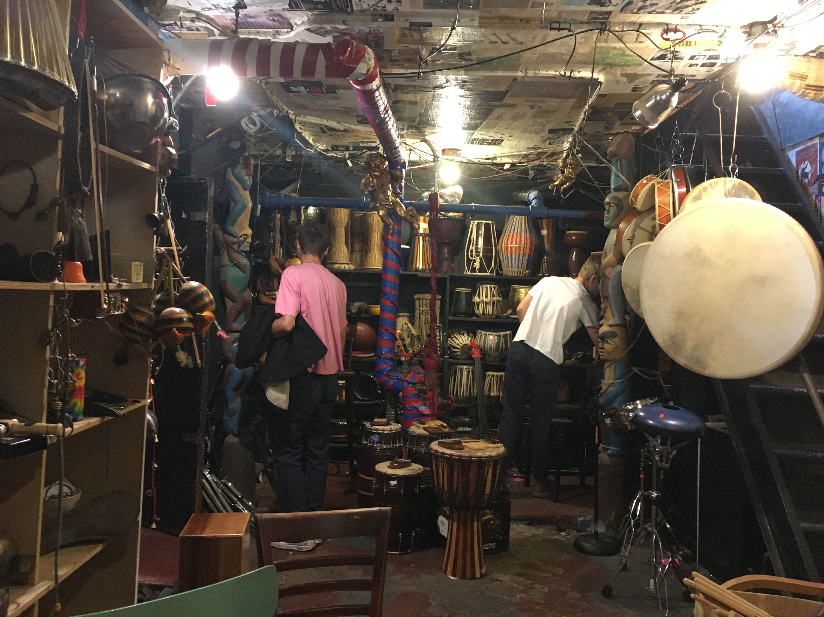 While Bill continued to critique different albums, I noticed a set of stairs leading to a basement. The two of us climbed down the steps, Bill nearly hitting his head on the low ceiling per consequence of being more than 5 and a half feet tall. Reaching the bottom of the stairs, we found ourselves surrounded by a hodgepodge of culture. The walls were covered by newspaper clippings and show posters, some signed by artists themselves, leaving only a few square feet of open space to show the faded yellow walls that lay underneath. Instruments from around the world, including djembes, cowbells, and rainmakers, were stacked precariously around the room, only interrupted by old piping running across the ceiling. Bill’s eyes immediately jumped to an old piano nestled under the space created by the stairs. As he started to hammer out “Heartbreaker” by Alabama Shakes, his face became consumed with a mixture of laughter and frustration as he realized that the piano’s center B key was mute. As the music played on in the background, I lazily ran my fingers over every instrument I could find, feeling the age of the store in every groove of wood and wrinkle of leather. I slowly made my way to a stool behind Bill, making sure to not interrupt his personal euphoria induced by the ivory keys. As I leaned my head back against a rusted pipe and closed my eyes to take in the sound, a familiar voice said, “You play?”

We both looked up to find the old man holding the cup of coffee he had journeyed out of the shop to find. Bill chuckled and sheepishly replied, “A bit”.

“Well don’t let me stop you,” the man stated as he sank into a wooden chair in the middle of the room.

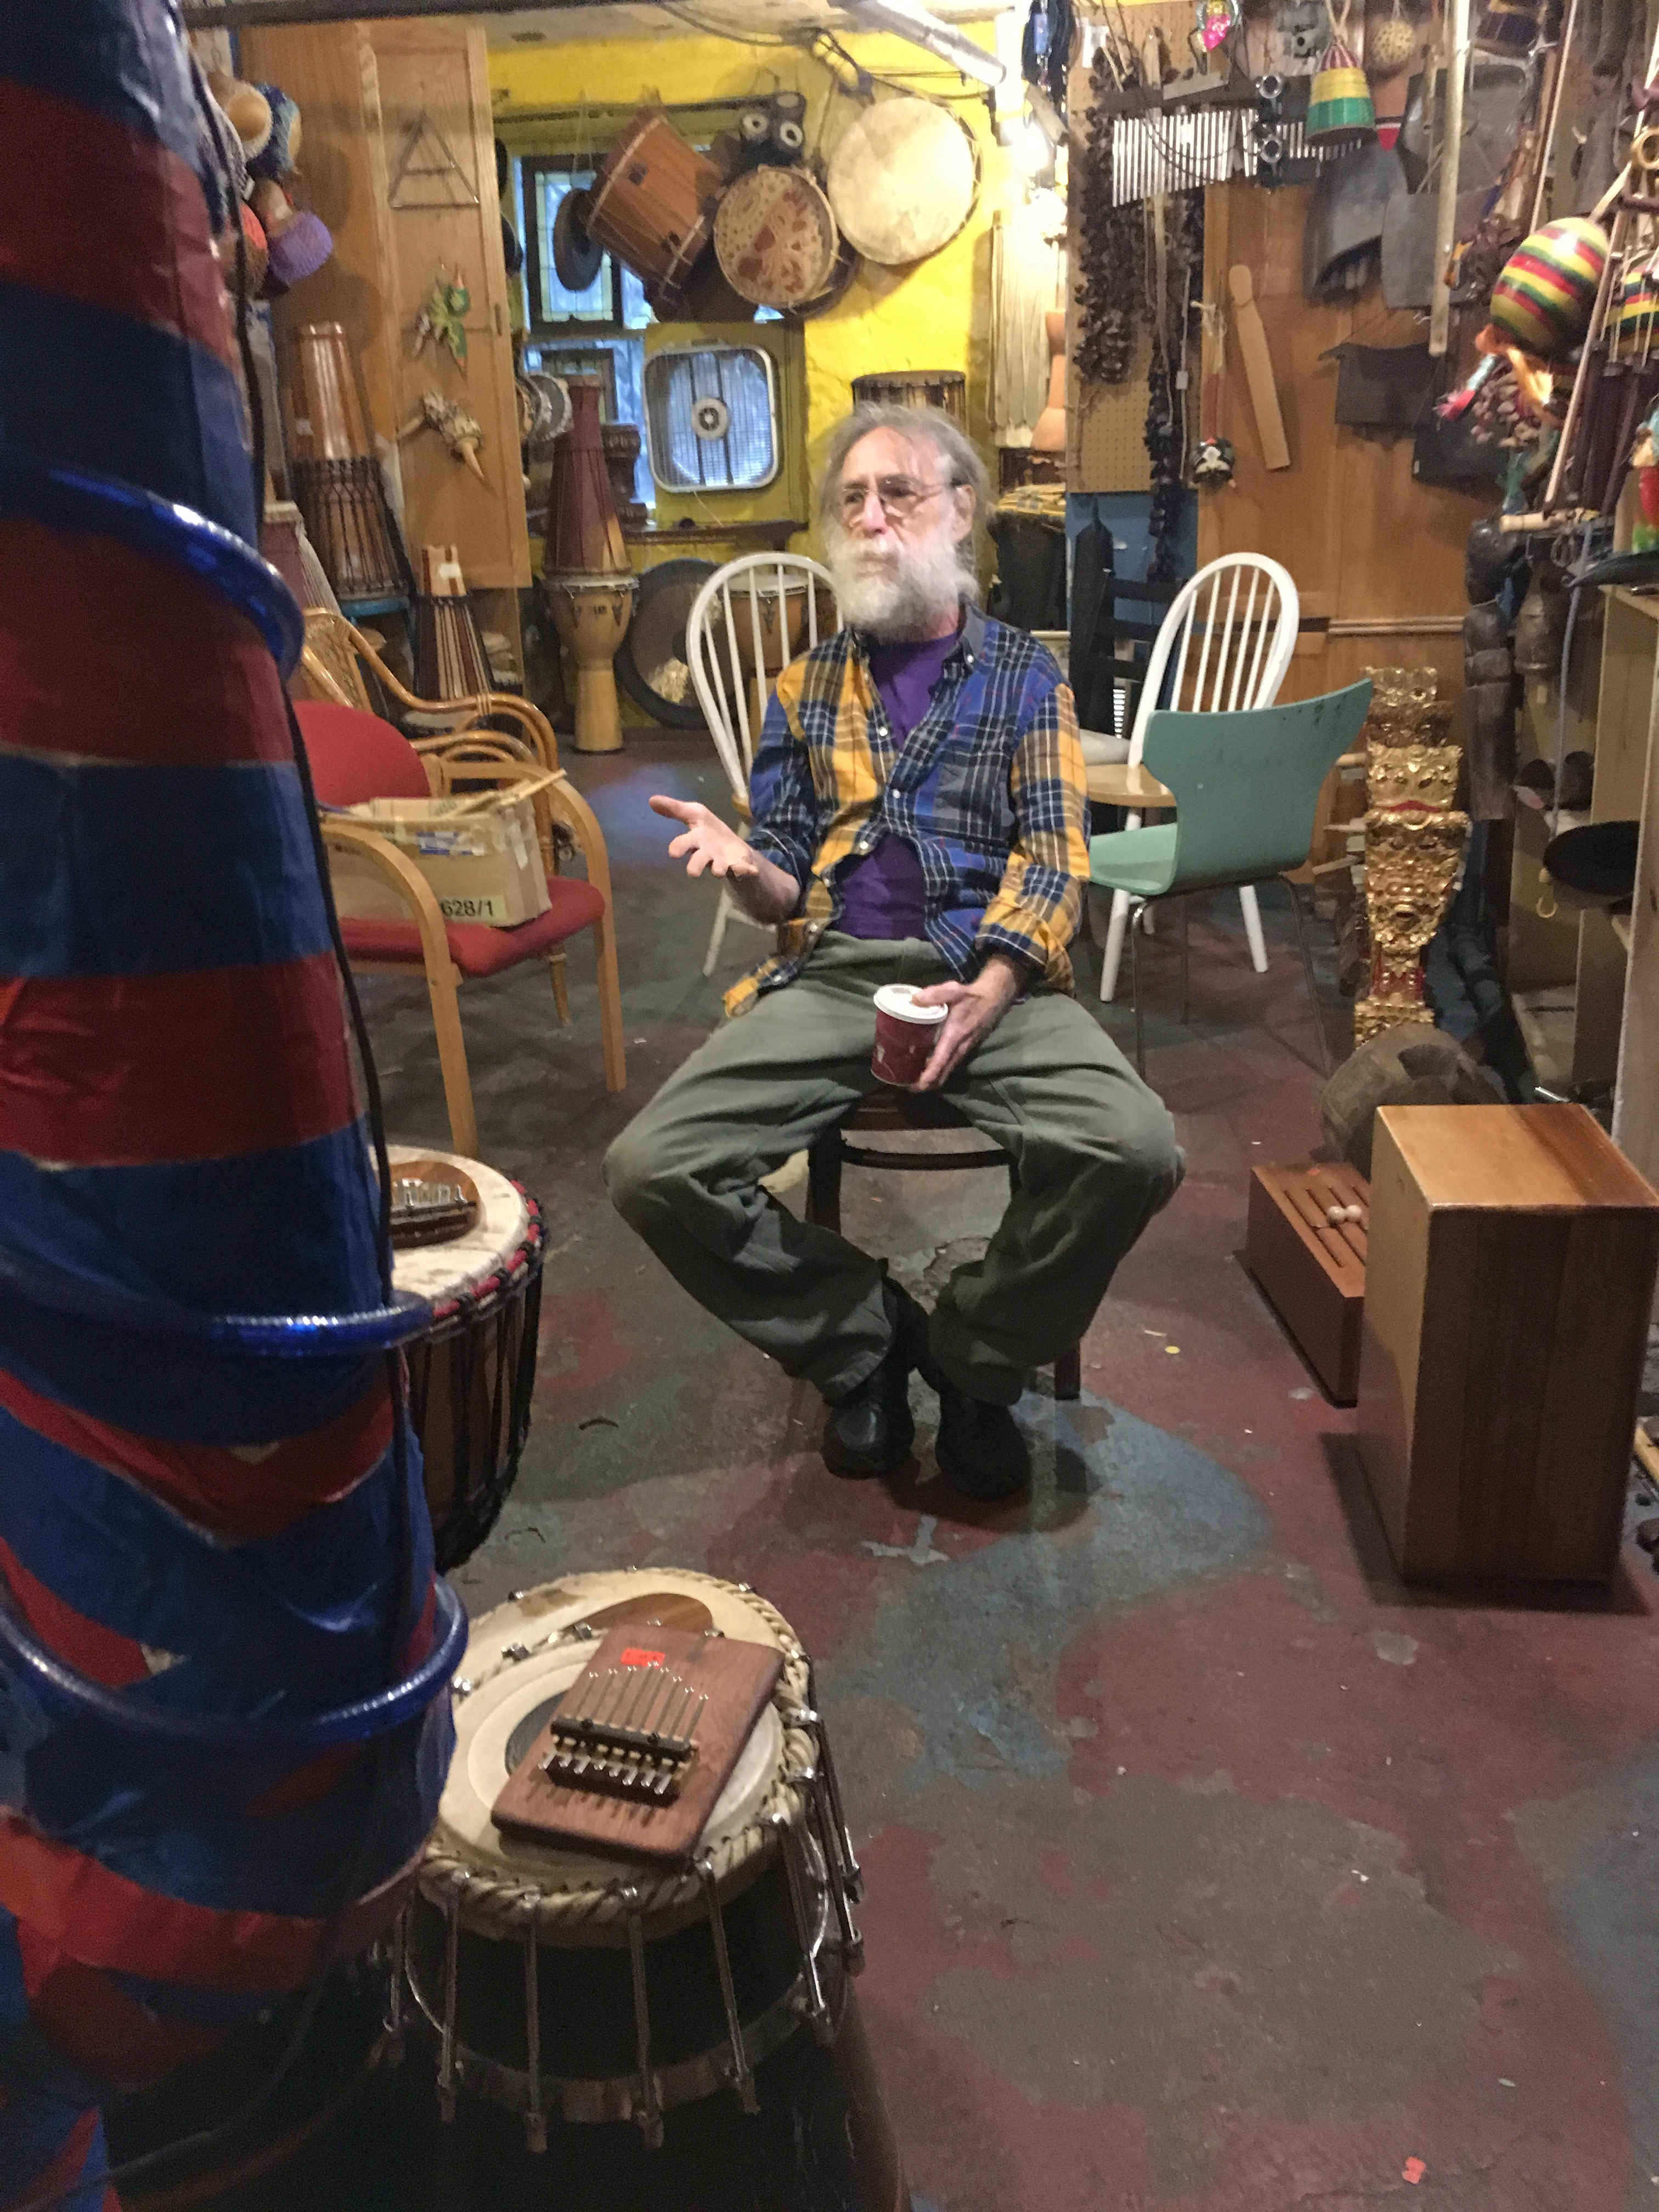 However, the man’s statement was a false promise, for every time he recognized a sound Bill produced, he interjected to comment and ask questions. The questions turned into the man singing along to Bill’s music, always a second behind the actual melody. To mask my amusement, I used a natural pause in Bill’s playing to ask the man who he was. He replied that his name was Jeff Slatnick, and that he is the owner of the store.

Jeff then turned to me and asked, “Do you play as well?”

I laughed, and replied “I played violin at Renaissance fairs when I was younger”.

Before I could continue, Jeff exclaimed, “Oh! I played a renaissance fair once. My friend was a tightrope walker, and I played the guitar. We were really good too. So much so that a man pulled us aside and said we needed to move. He took us to a room and inside was Joni Mitchell and Led Zeppelin. She was *really* into me. They asked me, ‘Do you want to do cocaine with us?’ and I said ‘sure’”.

Jeff felt no need to clarify or elaborate upon his statement, and he looked at Bill and me with a deadpan expression. Not quite knowing what to do with our new friend’s oddly personal story, Bill and I exchanged mutual glances of amusement, and I asked the next rational question I could think of,

“So, did you meet any other musicians during your days?”

“Oh you have no idea,” Jeff said with a chuckle as a wistful look took over his face, “Music Inn has been home to every musician from the Village that you can think of- from Simon and Garfunkel to Dylan”.

Bill, eyes wide from the reference to Bob Dylan, asked, “Wait, how long have you been working here then?”

Jeff paused to count, “Well, the store opened in 1956, and I joined 8 years later in ’64- so 53 years now?”

Jeff explained that when he started work at Music Inn, the store was transitioning from selling only vinyl records to including inventory of second hand guitars donated by regular customers. Guitar sales were so successful that Music Inn’s staff decided that they should sell more than just guitars. Jeff was the main champion for the selling of global instruments, from African drums to Southeast Asian string pieces, which are the centerpieces of the store’s inventory today. Jeff noted that, “The Village has always been an incubator for producing new sounds within the music scene of the 1960’s. However, Music Inn is the reason that the sounds of the Village developed from acoustic folk to the inclusion of world sounds: drums, mandolins, the works” (personal interview with J. Slatnick, 7 September 2017).

After learning about the history of Music Inn for the next two hours, Jeff’s initial comment seemed like an understatement. Music Inn became a notable music shop in the early 60’s, coinciding with the development of artists and bands including Bob Dylan, Blues Project, Simon and Garfunkel, and Jackson Browne. The artists would frequent Music Inn in search of new instruments, but the gatherings quickly turned into creative production. Jeff noted that, “[the musicians] would individually come in to try out a guitar, but then one would stumble upon a whistle or mandolin. And before you knew it, the sounds were combined into something new” (personal interview with J. Slatnick, 7 September 2017). It was the vibrant energy of the store that fueled the exploration of new ideas and experimentation with music styles.

Thanks to the personal relationship Jeff fostered with them, artists still make visits to Music Inn fairly regularly. Paul Simon introduced Jeff to each of his wives before their marriages, and would always return, “to play a new guitar and hack out a therapy session” (personal interview with J. Slatnick, 7 September 2017). When he visits the Village, Bob Dylan makes sure to visit Music Inn and pay homage to the institution that supported his origins in American folk music. Music Inn still continues to support the growth of new artists, such as The Tallest Man on Earth, through open-mic nights every Thursday and opening its front door to anyone who wants to strum a guitar or work out a song on the basement piano. Whether they are a first-class act returning home, or two college students looking to hammer out a tune on some ivory keys, Music Inn has no criteria for who is to receive its hospitality.